Application: Logo Manipulation
In this section we will show you how to fill in the white lettering of the Coca-Cola logo below with a background image.
In [14]:
Image(filename='Logo_Manipulation.png')
Out[14]:
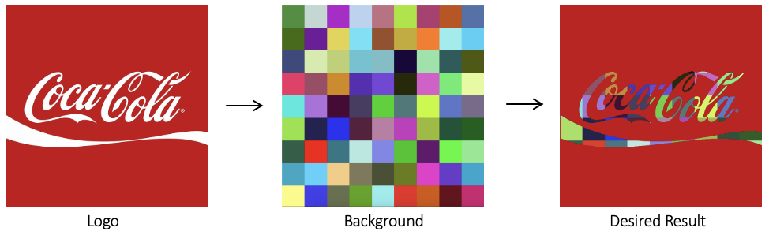

Read Foreground image
In [15]:
img_bgr = cv2.imread("coca-cola-logo.png")
img_rgb = cv2.cvtColor(img_bgr, cv2.COLOR_BGR2RGB)
plt.imshow(img_rgb)

print(img_rgb.shape)

logo_w = img_rgb.shape[0]
logo_h = img_rgb.shape[1]
(700, 700, 3)
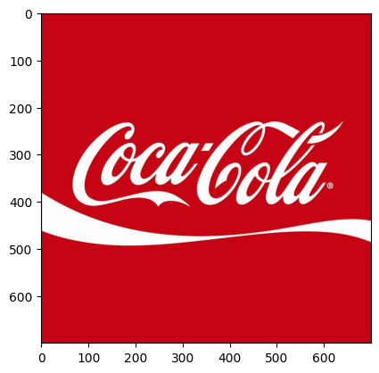

Read Background image
In [16]:
# Read in image of color cheackerboad background
img_background_bgr = cv2.imread("checkerboard_color.png")
img_background_rgb = cv2.cvtColor(img_background_bgr, cv2.COLOR_BGR2RGB)

# Set desired width (logo_w) and maintain image aspect ratio
aspect_ratio = logo_w / img_background_rgb.shape[1]
dim = (logo_w, int(img_background_rgb.shape[0] * aspect_ratio))

# Resize background image to sae size as logo image
img_background_rgb = cv2.resize(img_background_rgb, dim, interpolation=cv2.INTER_AREA)

plt.imshow(img_background_rgb)
print(img_background_rgb.shape)
(700, 700, 3)
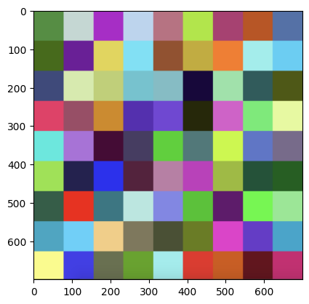

Create Mask for original Image
In [17]:
img_gray = cv2.cvtColor(img_rgb, cv2.COLOR_RGB2GRAY)

# Apply global thresholding to creat a binary mask of the logo
retval, img_mask = cv2.threshold(img_gray, 127, 255, cv2.THRESH_BINARY)

plt.imshow(img_mask, cmap="gray")
print(img_mask.shape)
(700, 700)
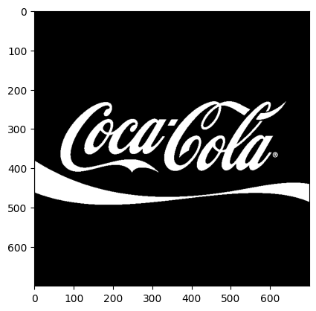

Invert the Mask
In [18]:
# Create an inverse mask
img_mask_inv = cv2.bitwise_not(img_mask)
plt.imshow(img_mask_inv, cmap="gray")
Out[18]:
<matplotlib.image.AxesImage at 0x15c6b09f100>
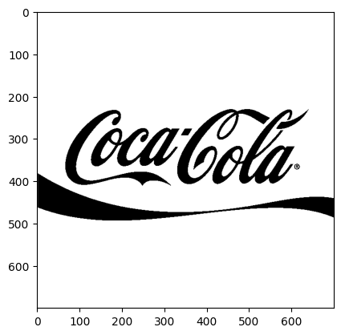

Apply background on the Mask
In [19]:
# Create colorful background "behind" the logo lettering
img_background = cv2.bitwise_and(img_background_rgb, img_background_rgb, mask=img_mask)
plt.imshow(img_background)
Out[19]:
<matplotlib.image.AxesImage at 0x15c6b12e170>
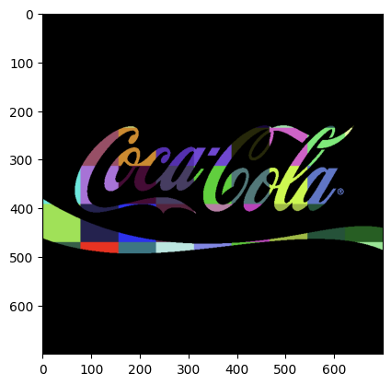

Isolate foreground from image
In [20]:
# Isolate foreground (red from original image) using the inverse mask
img_foreground = cv2.bitwise_and(img_rgb, img_rgb, mask=img_mask_inv)
plt.imshow(img_foreground)
Out[20]:
<matplotlib.image.AxesImage at 0x15c6b089420>
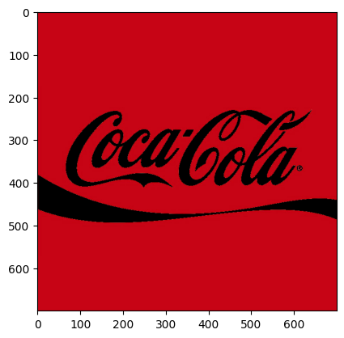

Result: Merge Foreground and Background
In [21]:
# Add the two previous results obtain the final result
result = cv2.add(img_background, img_foreground)
plt.imshow(result)
cv2.imwrite("logo_final.png", result[:, :, ::-1])
Out[21]:
True
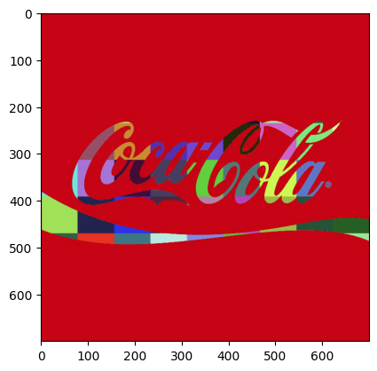

Thank You!

TASK : IMAGE FILTERING

import cv2
import sys
import numpy

PREVIEW = 0 # Preview Mode
BLUR = 1 # Blurring Filter
FEATURES = 2 # Corner Feature Detector
CANNY = 3 # Canny Edge Detector

feature_params = dict(maxCorners=500, qualityLevel=0.2, minDistance=15, blockSize=9)
s = 0
if len(sys.argv) > 1:
s = sys.argv[1]

image_filter = PREVIEW
alive = True

win_name = "Camera Filters"
cv2.namedWindow(win_name, cv2.WINDOW_NORMAL)
result = None

source = cv2.VideoCapture(s)

while alive:
has_frame, frame = source.read()
if not has_frame:
break

frame = cv2.flip(frame, 1)

if image_filter == PREVIEW:
result = frame
elif image_filter == CANNY:
result = cv2.Canny(frame, 80, 150)
elif image_filter == BLUR:
result = cv2.blur(frame, (13, 13))
elif image_filter == FEATURES:
result = frame
frame_gray = cv2.cvtColor(frame, cv2.COLOR_BGR2GRAY)
corners = cv2.goodFeaturesToTrack(frame_gray, **feature_params)
if corners is not None:
for x, y in numpy.float32(corners).reshape(-1, 2):
cv2.circle(result, (x, y), 10, (0, 255, 0), 1)

cv2.imshow(win_name, result)

key = cv2.waitKey(1)
if key == ord("Q") or key == ord("q") or key == 27:
alive = False
elif key == ord("C") or key == ord("c"):
image_filter = CANNY
elif key == ord("B") or key == ord("b"):
image_filter = BLUR
elif key == ord("F") or key == ord("f"):
image_filter = FEATURES
elif key == ord("P") or key == ord("p"):
image_filter = PREVIEW

source.release()
cv2.destroyWindow(win_name)

